Jett Tinik

Prof. Lu

PEP 336

22 March 2022

Lab 1 Report

“I pledge my honor that I have abided by the Stevens Honor System” - Jett Tinik

1. This lab aims to calculate the kinetic/potential energy of a specific binary star system. In this case, we are looking at the stars Sirius A and Sirius B. After entering the parameters of the mass of the parent star, semi-major axis, and orbital eccentricity, we are able to obtain data at specific timestamps. With this data, we can plot the relationship between reduced mass vs the parent star during the orbit.
   1. This lab will help increase my understanding of data engineering
   2. This lab will help increase my understanding of binary star systems and how they orbit

Trial Run of the Code

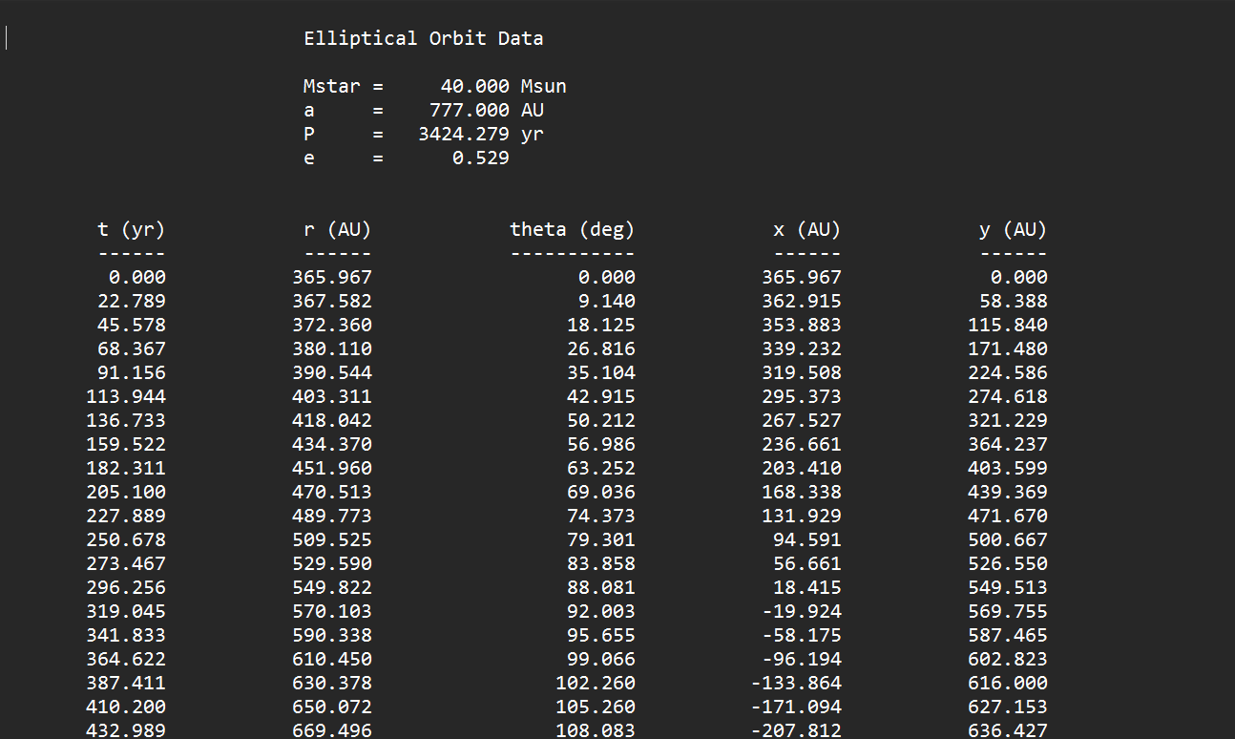

2.

Here is the output data formulated into my Notepad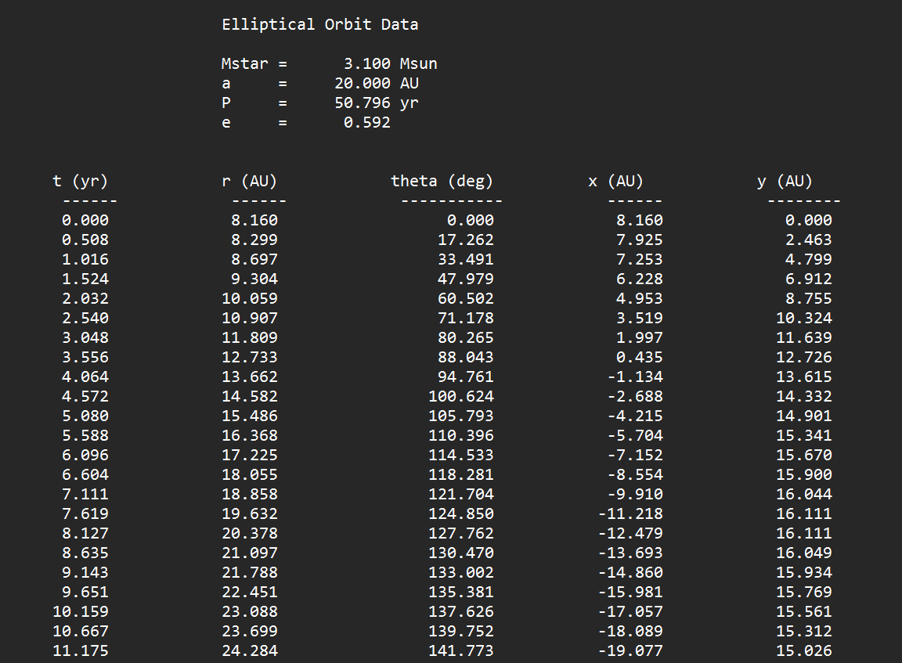

Here is the command line interface

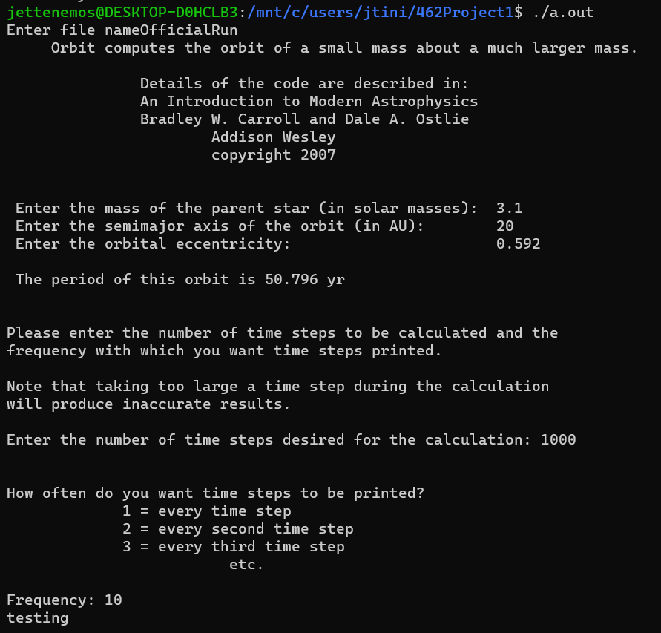

Here is the X and Y coordinate plot of the binary orbit

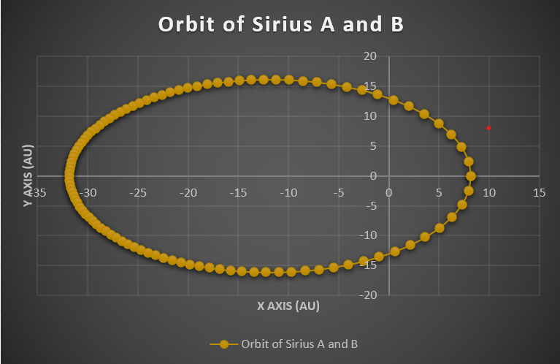

3.

Here is a screenshot of the equations for KE and PE that I added to the code provided

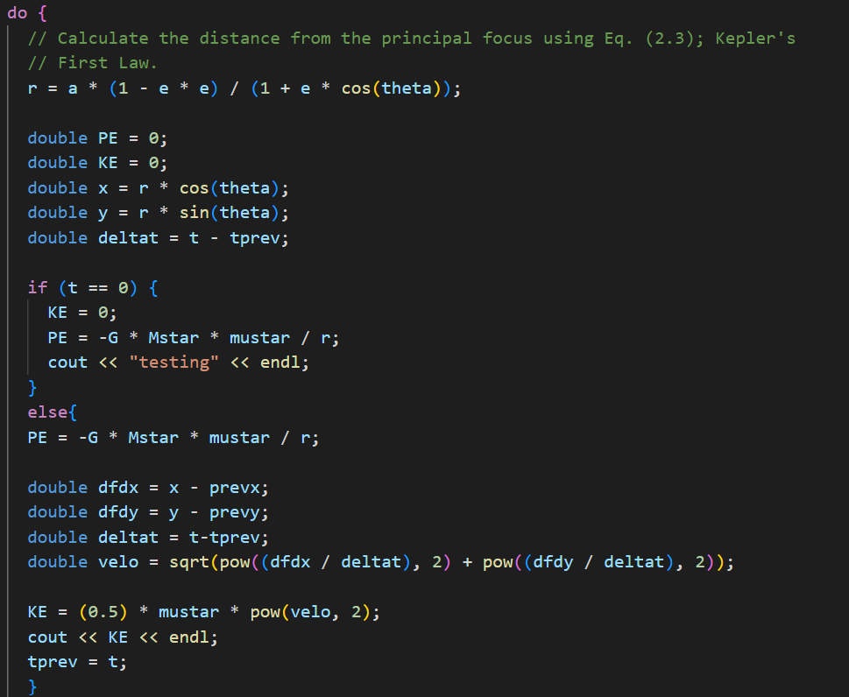

Here is the graph of Kinetic Energy and Potential Energy along the orbit path

